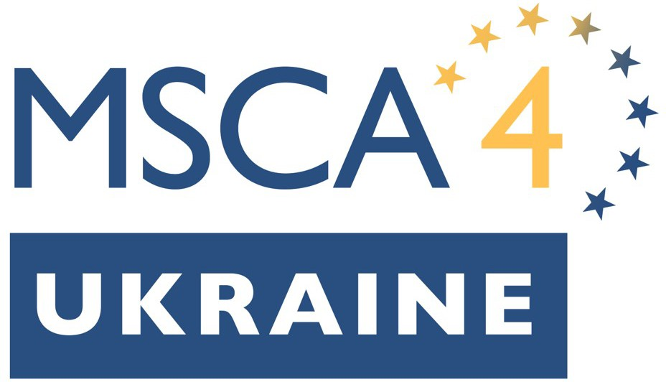
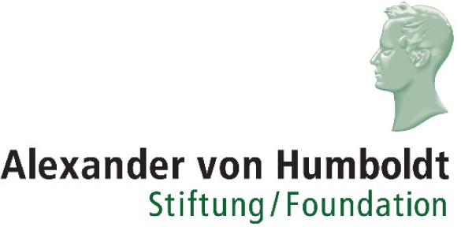

List of questions
to be answered in the statement of the host organisation

Please prepare a signed statement on your organisation’s letterhead outlining in no more than 1.500 words the support to be provided to the candidate, by responding to each of the questions below.

- What position or role will the candidate hold within your organisation?
- Please outline the candidate’s compatibility with the host organisation, for example departmental strength in the candidate’s research area, or, in the case of PhD holders, a void that the research can successfully fill.
- Please describe the profile of the academic mentor proposed for this candidate. If applicable, please provide details on their experience hosting international guest scholars, in particular any experience hosting researchers at risk.
- Please provide details of training activities to be offered to the candidate, focused on developing new scientific knowledge through original research on personalised projects. Please outline any complementary training related to the career status of the fellow to be provided to develop key transferable skills and competences common to all fields, foster innovation and entrepreneurship, and promote and (where appropriate) reward Open Science practices.
- Please outline any practical support measures you have planned for the candidate, in particular any support you intend providing to fellows and family members to access accommodation, medical services, schooling and other social supports, as applicable.
- A secondment is an optional component of the application and can be up to a third of the fellowship duration. Secondments can still be planned after the fellowship is underway. Please provide details of any secondments envisaged as part of the MSCA4Ukraine fellowship, either within Ukraine, in another EU country, Horizon Europe Associated Country or other third country as part of the MSCA4Ukraine fellowship. This might include, for example, a secondment to the candidate’s home institution in Ukraine for part of the fellowship duration in order to facilitate return if safe conditions for return are met.
- If you have outlined plans for a secondment in question 4 above, please confirm here that as the applicant organisation, if your application is successful, you understand that your organisation would continue as the employer for the full duration of the MSCA4Ukraine fellowship, including during any secondment undertaken by the candidate in Ukraine or elsewhere. Responsibility for reporting on the progress of the fellowship will lie with your organisation for the duration of the fellowship.
- In addition to, or instead of any proposed secondment, please outline any measures envisaged during the fellowship to maintain or strengthen the candidate’s connections to research and innovation communities in Ukraine. Such measures might include double affiliations, joint supervision of doctoral candidates, facilitating continued distance learning, continued distance teaching, or other measures.
- Please provide an explanation of the requested fellowship duration in respect to the specific needs and interests of the candidate, including related training and support concepts. The minimum allowed fellowship duration is 6 months; the maximum is 2 years. If the duration requested is less than two years, please clarify why this duration is in the best interest of the researcher. If the duration requested is because, for example, the researcher’s intention is to return to Ukraine after 6 months, please demonstrate the realistic short-term measures that are underway or planned to prepare for such reintegration.

